***These instructions set the template for acceptance into the Proceedings of the 31st International and Mediterranean Conference - MeditMaint 2026. The selected Articles can also be published in the HDO journal Maintenance and Exploitation (cro. Održavanje i Eksploatacija) or Journal of Energy (cro. Energija).***

Short Guidelines for Authors:

- Use this template directly when writing and formatting your paper.

- Please use font Arial 9 pt for the full text.

- Select the appropriate HDO formatting style (see inside [square brackets] in this template for style names) for your text by looking in the “Home” tab in the “Styles” box, e.g., use [Style: HDO Body text] for the body.

- Fill in the Article Information table, using [Style: HDO_Heading and HDO Body text].

- In the author list, please use an * (asterisk) to mark the corresponding author. In the case of a single author, the asterisk is not required.

- Please limit the number of authors and do not list more than 6 authors.

- In case of all authors of the paper having the same affiliation, superscript letters should be omitted.

- Please use just one (main) affiliation for each author, and others should be in the Acknowledgments section.

- The email of the corresponding author should be provided on a separate line after the affiliations.

- Delete this guide page and write your article directly in this template.

Enter ENG paper title here [Style: MeditMaint Paper Title]

Unesite HR naslov rada ovdje [Stil: Naslov rada MeditMaint]
Name Surnameª, Hrvoje Horvat^{b,}*, <first and middle names> <family name> [Style: HDO Authors]
ªAffiliation, Address, ZIP code City, Country (do not include email) [Style: HDO Author information]
^{b}Affiliation, Address, ZIP code City, Country (do not include email) [Style: HDO Author information]
*corresponding.author@domain.hr [Style: HDO Author information]
ARTICLE INFORMATION |  | ABSTRACT
Category: |  | A concise and factual abstract is required. The abstract should state briefly the purpose of the research, the principal results and major conclusions, and should not exceed 200 words. An abstract is often presented separately from the article, so it must be able to stand alone. The following template contains examples of paragraph styles and formatting. While browsing the template, the styles change in the Style drop down combo box (usually placed in the upper left corner of the MS Word 2003 window as part of the Formatting toolbar, activated with the menu command: Format > Styles). The preferred display settings should be Show: "Available Styles" for clarity. Use the text in this template as a guideline on which style to select for specific text categories (Authors' names, keywords etc.). The guidelines and examples provided in this document can sometimes be modified to suit specific layouts. When deviating from the template, one should regard the article conformity in regard to the overall journal layout. Some layout changes could occur, compared to the submitted manuscript, when the final typeset is done.  Authors who are native Croatian speakers should provide both an English and Croatian version of their abstract. For other authors, the abstract will be translated to Croatian.
Select

Keywords:
Define 3-5 keywords.

License: CC BY-NC-SA 4.0.

INFORMACIJE O ČLANKU |  | SAŽETAK
Kategorija:  Odaberi |  | Potreban je sažet i činjenični sažetak. Sažetak treba ukratko navesti svrhu istraživanja, glavne rezultate i glavne zaključke, a ne smije biti duži od 200 riječi. Sažetak se često predstavlja odvojeno od članka, tako da mora biti samostalan. Ovaj predložak sadržava primjere stilova odlomaka i formatiranja teksta. Za MS Word 2003 su dostupni preko naredbe Format>Styles i pojave se u kombiniranom panelu Styles and Formatting koji je obično u desnom dijelu MS Word prozora. Poželjno je prikaz ("Show") postaviti na "Available Styles" radi preglednosti. Koristite tekst u ovom predlošku kao primjer odabira stilova za pojedine kategorije teksta (imena autora, ključne riječi i sl.). Smjernice i primjeri koji se nalaze u ovom dokumentu se ponekad mogu prilagoditi kako bi odgovarali specifičnim prijelomima. Kada se odstupa od predloška, treba se uzeti u obzir podudarnost u članku sa cjelokupnim prijelomom časopisa. Neke se promjene u prijelomu mogu pojaviti, usporedbom sa predanim rukopisom, pri završnom slogu i prijelomu.  Članci autora hrvatskog govornog područja trebaju sadržavati sažetak na engleskom i hrvatskom jeziku. Za autore drugih govornih područja tekst sadržaja će biti preveden.
Ključne riječi:
Definirajte 3-5 ključnih riječi.

Licenca: CC BY-NC-SA 4.0.

Symbols/Oznake

e_{hyd} | - specific hydraulic energy, m²s⁻²  - specifična hidraulička energija | μ | - dynamic viscosity, Pa s  - dinamička viskoznost
g | - acceleration due to gravity, ms⁻²  - gravitacija | ρ | - density, kgm⁻³  - gustoća
H_{loss} | - hydraulic losses, m  - hidraulički gubici | φ | - general characteristic  - općenita značajka
H_{st} | - static head, m  - bruto pad | ω | - angular velocity, rad s⁻¹  - kutna brzina
HKSM | - wicket gate servomotor position, %  - hod klipa servo-motora
k | - turbulent kinetic energy, m²s⁻²  - turbulentna kinetička energija |  | Subscripts/Indeksi
k_{p} | - pipeline constant, , m⁵s²  - konstanta dovodnog cjevovoda | ₁ | - high pressure reference section  - referentni presjek visokog tlaka
 |  | ₂ | - low pressure reference section  - referentni presjek niskog tlaka
 | Greek letters/Grčka slova | _{HW} | - headwater  - gornja voda
ε | - turbulent dissipation rate, m²s³  - turbulentna disipacija | _{TW} | - tailwater  - donja voda
η | - turbine hydraulic efficiency, %  - hidraulička korisnost turbine | _{t} | - turbulent  - turbulentni
  - Introduction
This template is intended for clarification of issues regarding the layout and formatting of articles submitted for publication. The total number of pages in the article should be an even number, avoid blank pages. The article should be formatted in one column. Paragraph text should be formatted with the Normal style (Arial, 9pt – use style HDO Body text). There is no first line tab or other decorative paragraph formatting. The Font Arial should be used, as well for all other text (including text appearing in Figures). The title of the article is formatted with HDO 1. Heading style. Section headings are formatted hierarchically with styles HDO 1.1 Heading style and HDO_Heading style and are numbered automatically.

After the first page, which contains the abstract and introduction in English and Croatian, the top part of the second page should contain the table of symbols, Greek letters and subscripts, each in their alphabetical order, that are used in the article. Variables should be written in Italics, while subscripts and matrix designations should not. Matrices (J = [0]) should also be bold. Both principal article language (English or Croatian) and the translated meanings of symbols, Greek letters and subscripts should be listed, separated by a "/" slash. Measurement units, where applicable, should follow the principal article language, separated by a comma.

The introduction should continue after the table of symbols. The usage of the decimal comma (e.g. 1,2) is requested throughout the text, formulae, tables, and figures in case of Croatian articles. However, articles written in English can use the decimal point (e.g. 1.2) if this is kept consistent throughout the article text, formulae, tables, and figures.
    - Page layout
The layout of the pages must follow the current format - do not modify the page setup – including the header.
Instructions:
- Follow the word count limit and avoid having large empty spaces within text.
- Avoid using bold or italics in the text, as these are reserved for headings.
- Do not exceed the page’s margins with tables, text, or figures.
- Do not insert Headers, Footers, Footnotes, page numbers.
- Do not begin a new section at the bottom of the page, rather move the heading to the next page.
- Do not use horizontal page (landscape layout).
    - Section headings
Author guidelines:
- First-level heading should use [Style: HDO 1. Heading]
- Second-level heading should use [Style: HDO 1.1. Heading]
- Sections headings should use [Style: HDO_heading]
  - Equations, figures, tables, and measurements
    - Equations
Equations should be written using the MS word integrated MS Equation editor or inserted as a raster image. In the latter case, the equation should conform to quality demands for raster images (min. 300 dpi). For compatibility issues the most common fonts should be used (MS Equation editor menu command: Styles > Define). General text and numbers should be written by using regular font Times New Roman or similar. Variables, counting indexes and letters representing physical values should be written with the same font but in italics. The font Symbol in italics, or similar should be used for Greek letters.

Basic equation text height should be set to 10 pt while heights of other elements are given in the form of percentages. Equations should be sized as shown on figure 3 (MS Equation editor menu: Sizes > Define).

Author guidelines:

- To add equations, copy the borderless table (below) and insert your equation
- Write the equation reference number on the right side and reference as Eq. (1)
- Inside the equations, use font Arial, size 9 pt for the main text, if possible.
- Format line and text using [Style: HDO Equation] to ensure correct spacing around the equation (1):

$$X_{example}=\sum_{x=1}^{8784}{{XY∙Z}_{example}\left(x\right)}.$$ | (1)

    - Figures
Author guidelines:

- Figures and tables should be high-quality images as shown in Figure 1.
- Use high-resolution images enhanced with colour, lines and text that are readable.
- Images with captions both aligned to the left margin, ensuring the image(s) with caption are on the same page
- Two narrow figures may be placed side-by-side and must be referenced using “a” and “b”, i.e., Figure 1a
- Cross-references to figures (and tables) should use only the label and number, e.g., Figure 1

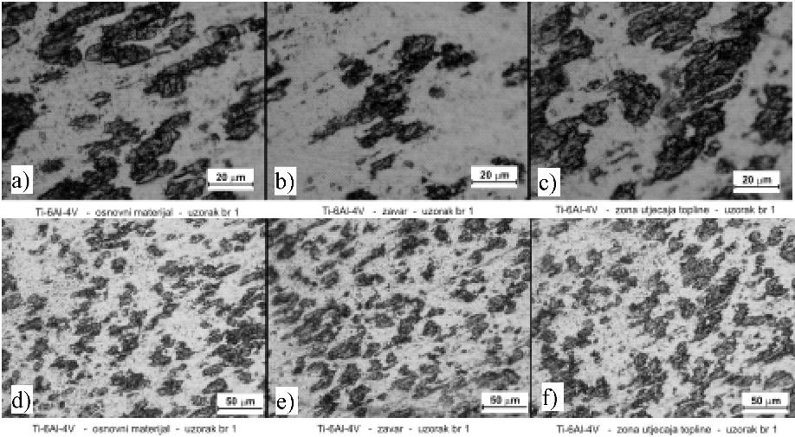

Figure 1. Metallographic photos of alloy Ti-6Al-4V (two different magnifications) – base material –weld-heat affected zone Etching: Kroll reagens 100 ml water, 2 ml HF, 5 ml HNO3 [Style: HDO Caption]
Slika 1. Metalografske slike legure Ti-6Al-4V (dva različita povećanja) - osnovni materijal – zavar – zona utjecaja topline Nagrizanje: Kroll-ov reagens 100 ml voda, 2 ml HF, 5 ml HNO3 [Style: HDO Caption]
Small figures like Figure 2 should be sized to fit the width of a single column (or less, centered). Figures should be greyscale or B/W raster images with a preferred resolution of at least 300 dpi. The text occurring in figures properly sized for the final layout should also not be larger than 9pt, Arial, and it should also follow the bilingual guidelines set for table contents (principal article language/translated). Using embedded graphical objects as well as editable vector graphics should be avoided because of compatibility issues (including WordArt).
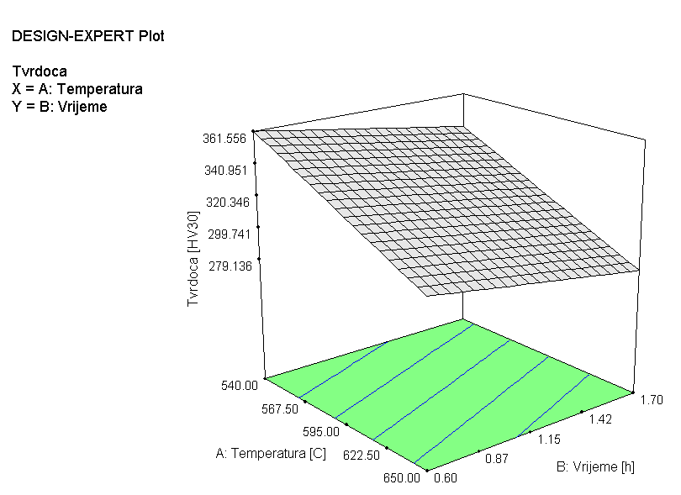
Figure 2. 3D diagram of mathematical model [Style: HDO Caption]
Slika 2. 3D dijagram matematičkog modela [Style: HDO Caption]
    - Tables
Author guidelines:
- Copy and re-size the template table to your needs to ensure correct blue line colours
- Set the Table and title left-aligned.
- Place both table title and table on the same page.
- Horizontal lines should be placed above and below table headings and at the bottom of the table.
- Do not add vertical border lines or use bold or italics font in tables.

Table 1. Example of placing small table in a column-formatted text [Style: HDO Table title]
Tablica 1. Primjer postavljanja male tablice u stupac formatiranog teksta [Style: HDO Table title]
Heading1 |  | Heading 2 | Heading 3 | Heading 4 | Heading …
Row 1 |  | Column 1 | Column 2 | Column 3 | Column 4
Row 2 |  | Column 1 | Column 2 | Column 3 | Column 4
… |  | … | … | … | …
    - Measurement values and units
Author guidelines:
Be consistent and accurate with the reporting of measurements and units.
Use SI units, where possible, e.g., the unit for a year is “y”, not “a”, similarly, “h” for hours.
Use ISO symbol style – e.g., CO₂ and not CO2.
Be accurate with the measurement units, e.g., “Km” does not mean “kilometres”, but “Kelvin-meters”.
Always use a space between values and units, e.g., 500 m, 10 %, 0 °C, 273.15 K.
Please do not mix °C and K in the same paper, more preferred is °C.
Please use the British style for numbers, i.e., 1,000,000.23, using a comma as the thousands separator and the dot is the decimal separator.
    - Lists
Lists should be formatted with the style HDO List bullets.
Preceding character is a long dash,
It is slightly indented as to differ from the text body using commas to separate list items and a full stop after the last item.
  - Conclusions
It is mandatory to have conclusions in the manuscript, which point out the significance of the presented study. Please include quantitative results to strengthen appropriate conclusions. Avoid writing a second abstract.
Acknowledgements
If applicable, write acknowledgements after the Conclusions section using style [Style: Body text].
References
The list of references should appear at the end of the article under the title REFERENCES. Listed references should be numbered according to the order of their first appearance in the article text. References must be prepared according to the style in the example below using [Style: HDO Reference text].

Instructions:
- Cited references [1] in the article text should consist of the publication's reference number [2] in brackets separated with a comma when citing two or more (e. g. [3], [4] and [5]) consecutive references. However, please eliminate all reference lumps by characterising each reference individually. This can be done by mentioning 1 or 2 phrases per reference to show how it is different from the others and why it deserves mentioning.
- Articles “in press” can only be referenced if accepted and assigned a DOI, do not use “in press”.
- When referencing conference proceedings, page (or lecture, poster) number(s) should be provided.
- Remove hyperlinks (blue colour and underlining) from web references.
- For books, theses and reports, please provide the city and country of publication.
- The references should be listed in numerical order as they appear in text in the Reference list.
- All contributing authors should be listed for each reference.

Example of correctly formatted references. Indicate references by number(s) in square brackets in line with the text. Text: The actual authors can be referred to, but the reference number(s) must always be given.
List: Number the references (numbers in square brackets) in the list in order in which they appear in the text. Note shortened form for last page number. e.g., 51–9, and that for more than 6 authors the first 6 should be listed followed by 'et al.'

Reference to an article in a journal or proceedings:
- Van der Geer J., Hanraads J.A.J., Lupton R.A. The art of writing a scientific article. Journal of Science Communication 2010;163:51–9. https://doi.org/10.1016/j.Sc.2010.00372.
- Živković D., Gabrić I., Šitić S. Analysis of heat treatment influence on the hardness of steel EN 42CrMo4. Conference proceedings MATRIB 2012, Vela Luka, Korčula; 2012, p. 379-386. https://hdmt.hr/wp-content/uploads/2021/02/MATRIB-2012.pdf.

References to the journal article with article number:
- Van der Geer J, Hanraads JAJ, Lupton RA. The art of writing a scientific article. Heliyon. 2018;19:e00205. https://doi.org/10.1016/j.heliyon.2018.e00205.
- Gao W., Ge S. A comprehensive review of slope stability analysis based on artificial intelligence methods. Expert Systems with Applications. 2024; 239: 122400. https://doi.org/10.1016/j.eswa.2023.122400.

Reference to a book:
- Strunk Jr W, White EB. The elements of style. 4th ed. New York: Longman; 2000.

References to the chapter in the edited book:
- Mettam GR, Adams LB. How to prepare an electronic version of your article. In: Jones BS, Smith RZ, editors. Introduction to the electronic age, New York: E-Publishing Inc; 2009, p. 281–304.

Reference to a web page:
- HROTE – Hrvatski operator tržišta energije d.o.o. OiE I KOGENERACIJA. Poticajne cijene. OiE sunčane elektrane instalirane snage ≤ 5 MW. https://files.hrote.hr/files/PDF/HR_OIE_1_SE_2014.pdf; 2014 [Pristupljeno 19 studeni 2023].

Reference to the dataset:
- [dataset] European Comission. Data. Quick search. Weather forecasts up to 9 days. Air temperature; 2023. https://data.europa.eu/data/visualisation/?file=https%3A%2F%2Fdata.gov.lv%2Fdati%2Fdataset%2F76c7e3fe-2a07-4164-a391-9bca8e039992%2Fresource%2F7af98218-6266-4459-a79d-a7dfe29277e0%2Fdownload%2Ft.csv [Pristupljeno 19 studeni 2023].

